Name:  Teacher: | ____________________________________  ________________ |  | Date:_________
 | Year 11 Mathematics Essentials  SCORE: / 57  Topic – Percentages, Ratios and Rates  Full working out MUST be shown to get full marks for each question.
Total Time: | 50 minutes
Weighting: | 10 %
Equipment: | To be provided by the student: Pens and Pencils, scientific calculator, A4 page of notes.

Question 1: [5 marks]
City Beach Surf Shop is having a Winter Sale to clear out their Summer gear.
- If a T-shirt that normally costs $90 is on sale for 15% off what is the new price?

- When paying for the t-shirt, City Beach offers an extra 5% discount at the till if paid with cash. How much is the T-shirt worth if a customer pays with cash?

- A Scuba set (goggles and fins) originally cost $120 but is discounted by 20%. At the till the customer pays with their credit card, which has an additional fee of 2%. What is the overall percentage discount for the scuba set?

Question 2: [7 marks]
- Calculate the simple interest earned on an investment of $2540 at 9% p.a. for 2 years.

- Calculate the simple interest earned on an investment of $5320 at 6% p.a. for 14 months.

- Sally made loan repayments totalling $4320 on an initial loan of $4000 over 4 years. Calculate the rate of interest charged on the loan.

- Tara takes out a car loan of $6000 at a simple interest rate of 8% p.a. She plans to repay the loan over 2 years. What will her monthly repayments be?

Question 3: [2 marks]
  - In a class of 40 students there are 15 girls; Write the ratio of boys to girls as a simplified ratio.
  - What percentage of the class are boys?
Question 4: [4 marks]
Three friends bought a lottery ticket for $20; Sophie put in $10, Karen paid $6 and Tony paid $4. They agreed that if they won any money, they would split it in the ratio of the money they each put in. [4 marks]
  - What is the simplified ratio of the amount each person paid?
  - If they won $1000 how much would each person get?
Question 5: [6 marks]
- Circle two rates that are equivalent:

- Writing 34 words per second
- Writing 68 words in 30 seconds
- Writing 714 words in 21 minutes
- Writing 816 words per hour
- Writing 34 words per minute

- A cyclist travels 70 metres per 10 seconds. What is the speed of the cyclist in metres per minute?

- A local cyclist thinks that she can ride her bike as faster than Usain Bolt can run; if the cyclist timed herself over 1km and it took 2 minutes, and Usain Bolt’s 200m record is 20 seconds which one is going the fastest?

Question 6: [3 marks]

Use the diagram below to answer the following questions
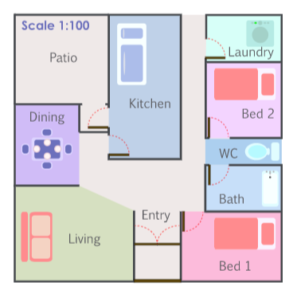

- According to the scale on the diagram. 1 cm represents how many metres in the house?

- Using a ruler Jill measured the length of Bedroom 1 on the plan and finds it to be 4 cm. How many metres is this?

- Jill measured the width of Bedroom 1 and finds it to be 8.5 cm. How many metres is this?

Question 7: [3 marks]

A piece of rope is cut into three lengths in the ratio of 2:3:5. If the smallest length is 6m, find the length of the original rope.

Question 8: [4 marks]

At Mad Mike’s Petrol Station there is a special promotion happening that lets customers fill up their tank for a flat price of $80 regardless of how much fuel they buy.

Next door is Baldy’s Boring Petrol Station which has no specials, just the standard price of 147.9 cents/Litre.

- If your tank is nearly empty and it normally takes 55 Litres to fill up, which petrol station is going to give you the best value for money?

- How much would you save with this option?

- In Mad Mike’s they sell six-packs of Coke for $15. How much does each can cost?

Question 9: [5 marks]

Spud Shed normally sells a large (10 kg) bag of Potatoes for $12, or a medium (4 kg) bag costs $5. Loose potatoes (pick as many as you want) cost $1.80 / kg.
- Put the three options in order from best value for money to worst value (show your working)

- If you are cooking a meal that requires 3 kg of potatoes which option would cost the least?

Question 10: [10 marks]

The following box and whisker graphs show the number of stocks (shares in the company) sold per day over a year. Answer the questions below that relate to these 3 graphs.

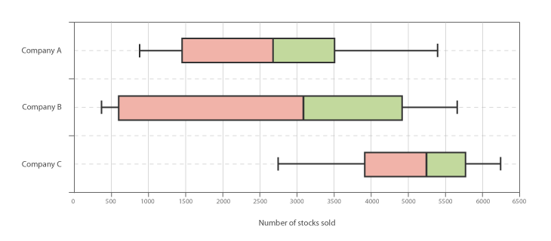

- Write out the 5-number summary of Company A:

- Company ________ has the highest median.

- Company ________ has the smallest interquartile range.

- Company _______ has the largest range.

- You are told that one of the companies had over 4000 stocks sold yesterday. Which company is this most likely to be and why?

Question 11: [2 marks]

Two classes sat a test and their results are shown below. Use the mean and standard deviation to compare the test results of the two classes.

 | mean | Standard deviation
Class A | 55% | 6.3
Class B | 57% | 8.1

Question 12: [6 marks]

The shapes of the graphs below can be described using the words “positive Skew”, Negative Skew”, “symmetrical” and “Bimodal”. Underneath each graph, write the most appropriate term.

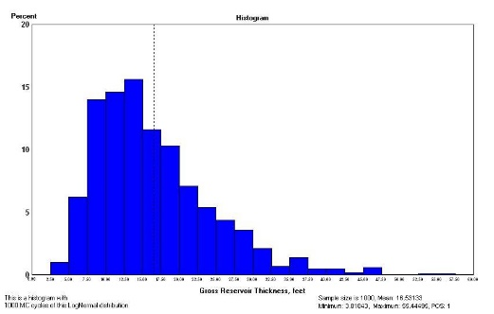
- B)
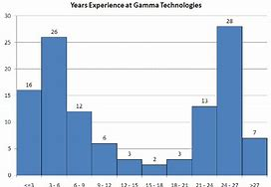

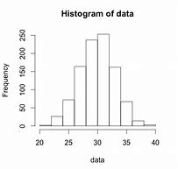
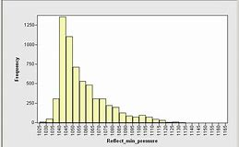
C) D)

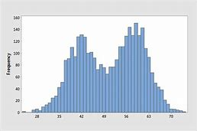
E) F)
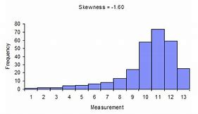

END OF TEST

